TERMS OF REFERENCE
ST PETERS QUARTER DERBY LTD - BID BOARD

NAME

The name of the body will be the ‘Board/Management Group of the ST PETERS QUARTER DERBY LTD (hereafter called the ‘BID Board).

BID MANAGEMENT STRUCTURE
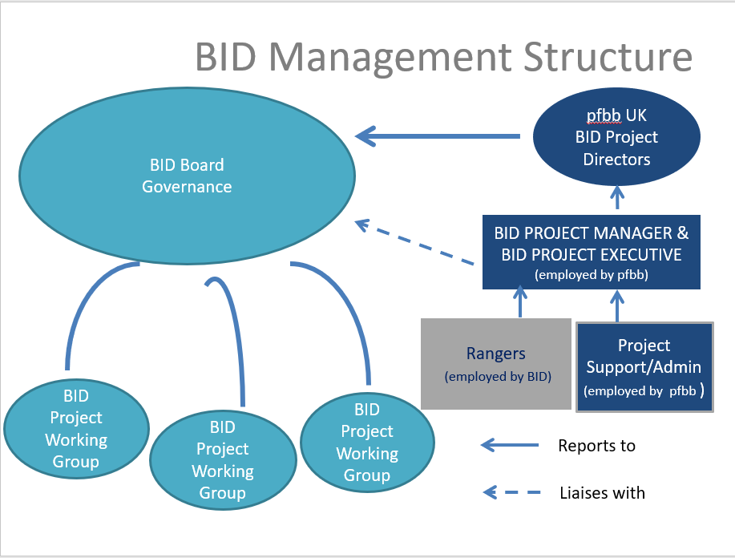

  - The BID Company has appointed Partnerships for Better Business Ltd (pfbb UK) to act as BID Project Management Consultants responsible for project delivery for the BID and they employ the BID Team (with exception of the Rangers who are employed by the BID but line managed by pfbb in conjunction with the Board Chair).

  - The management structure of the BID will be:
- A Board responsible for Governance.
- Individual members of the Board can act as BID Champions to support the BID Manager in advocating particular projects and acting as press spokespersons on behalf of the BID in relation to that project (see section 3.5).
- A BID Project Team comprised of a BID Project Director, BID Senior Project Manager, BID Project Executive, BID Rangers and a part time Administrator based in Derby. They have responsibility for the actual coordination and delivery of projects and activities in accordance with the BID plan, and will work closely with and provide information to the Board.
- Working Groups can provide support to the Project Team as a forum for helping to shape projects, and as a critical friend for idea and project development of individual projects.

The BID contracts SJJ PR to work with the Project Team to manage the PR. Social Media is managed by pfbb UK.

The Board will be elected by the members of the BID Company, drawn predominantly from those paying a levy in the area and made up of a representative cross-section of the businesses and stakeholders of the area and key agencies associated with the successful delivery of the BID project. It will be driven by the private sector.

  - All businesses will be encouraged to be actively involved in Working Groups to represent the levy payers.

  - Through specific working groups, the Project Team will be instrumental in prioritising the requirements of the levy payers into deliverable projects which address their needs, within the framework of the business plan.

  - Each group (Board and Working Groups) will have representatives from the BID Project Team attend at each meeting and who will provide agendas, minutes and follow through agreed actions.

ROLES
  - The Board will provide a consistent, collective and effective voice for the businesses in ST PETERS QUARTER DERBY (the BID area).

  - All roles on the Board and specific working groups are voluntary and are undertaken with a commitment to represent the interests of all businesses in the area.

  - The Board and BID Project team have a responsibility to ensure that the BID operates and delivers in line with the BID Vision and Objectives as outlined in the BID Business Plan.

The Project team have the day-to-day responsibility for direct project delivery in line with the Business Plan Objectives.

BID Board Members are encouraged to become project champions
    - Projects will be identified within the BID Business Plan project planning document.
- The role of a champion will be to act as an advocate and provide constructive support to the BID Manager. They will champion the project and the BID to other businesses/partners.
- The Board Project Champion may be asked (by the BID PR team) to provide quotes or speak to the media about the project and benefit of the BID, on behalf of the BID (as opposed to their own personal view). These requests will only come via the PR team, not from the media direct and we would encourage Board members/champions not to speak to the media direct without referring to the BID Project Team or PR consultant first.

ROLE OF THE BOARD & CHAIR

The main role of the Board is:

to safeguard the interests of levy payers by ensuring that the business operates in line with the BID plan as voted on at 24 February 2017 and commenced 1 April 2017

professional and offers consistent value for money in line with its targets.

To ensure that the development of action plans address the objectives of ST PETERS QUARTER DERBY LTD Business Plan within the agreed budgets and work towards achieving the vision and its related strategic objectives.

The Board will ensure that the implementation of the BID will be monitored and delivered cost-effectively, through keeping overheads to a minimum and using methods which will optimise the use of the revenue budget and add real value to the delivery of the plan.

To consider the development of a Business Plan and a successive Business Improvement District to succeed the current one which covers the period up to 31 March 2022.

To administer the operation of the ST PETERS QUARTER DERBY Ltd and to ensure that all legal, financial, contractual and corporate obligations of the ST PETERS QUARTER DERBY Ltd are met in accordance with the BID Regulations and an annual audit, review and report are undertaken and communicated to the businesses of the BID area.

To monitor and review the progress of the BID Business Plan to ensure that it is within budget to ensure it works towards the vision, objectives and activities identified in the Business Plan and does not deviate from it.

Collaborative working will be actively encouraged to build upon the sense of the business community in the BID area and ensure that the skills and resources available for delivery of the BID are enhanced and deliver best value.

  - The Board may modify budget allocations for each of the main projects and the management and administration of the BID in line with the BID Business Plan objectives and may take recommendations for modification from the project team, in order to ensure that the projects remain relevant and continue to address needs and priorities of the businesses in the BID during its five-year life.

  - It will be the responsibility of the Board to assess these recommendations and make adjustments to the allocations of expenditure budget as and when they deem appropriate. It will be the responsibility of the Board to ensure that all the main aims of the BID, continue to be addressed and that all BID activity contributes towards the achievement of the vision. The Board will also monitor and gauge the effectiveness of the BID operations and activities.

  - The Chair must be a representative from a business levy payer in the BID area and not a member of the Local Authority. Their role is to:

lead the group in the fulfilment of its role and adherence to its terms of reference.
- ensure that the BID Company Board leads the BID in the fulfilment of the vision, aims and objectives and its activities identified in the BID Business plan and not deviate from it.
- ensure that meetings of the Board are efficient and productive, all agenda items are covered within the appropriate timescale.

The role of the Vice Chair is to:

support the Chair in his or her role.

substitute for the Chair in his or her absence in meetings of the Board.

BOARD MEMBERSHIP
Extracts are taken from the ST PETERS QUARTER Derby Ltd Articles. The contents of which take precedent.
  - Unless otherwise determined by the Board from time to time, the Board shall be between 3 and 11 people and shall comprise the following:
  - up to 9 individuals’ representative of BID Members who should, as a group, be as representative as possible in terms of business size and type and geography of the BID and who shall at any time represent more than one half of the Board;
  - up to 2 individuals’ representative of partnership organisations including but not limited to Derby City Council (“Local Authority Directors”) and shall at no time represent more than one third of the Board;
  - up to 2 individuals’ representative of the Voluntary Members (the “Voluntary Member Directors”) and shall at no time represent more than a third of the Board;
  - up to 2 such individuals who, in the view of the Board, have particular skills or experience which will assist the Company to promote its Objects (the “Independent Directors”) and who shall at no time represent more than one third of the Board;

- The quorum for the transaction of the business of the Board shall be fixed at three Directors or one half of the Board whichever is the lower.

ROLE OF WORKING GROUPS

To support the BID Project Team
- In determining priorities, coordinating activity and maintaining active business involvement in the implementation of the Business Plan.

- In securing funding from a variety of sources including public and private sector contribution, revenue generation from sponsorship of specific activity.

- To bring together stakeholders from all aspects of business in the BID area to work in partnership and co-ordinate their activities towards the BID vision, ensuring regular, accurate two-way flow of information between the BID and these other stakeholders of the ST PETERS QUARTER DERBY BID area.

- To encourage all members of the BID business community to become involved in influencing and shaping the future of their business environment and supporting the BID objectives.

  - The Chair of each Working Group will tend to be the BID Manager or the Board Champion for that Group.

  - The role of the Chair is to:

- work closely with and support the members (BID Levy payers and relevant partners) in identifying opportunities to optimise value for money, identify and deliver relevant projects to ensure and further the fulfillment of the Business Plan objectives.

- ensure that meetings of the Working Groups are efficient and productive, all agenda items are covered within the appropriate timescale.

WORKING GROUP MEMBERSHIP

Any business that is a levy paying businesses operating in the ST PETERS QUARTER DERBY Business Improvement District as defined by the BID Business Plan is welcome to join the Working groups.

Businesses or organisations located outside of the area, with direct business interests in the area, are welcome to join by invitation of the BID Project Team as a voluntary member.

The group should have a broad representation from across business sectors and the geography of the Business Improvement District area.

The maximum size of the group should be no more than 15 people of which no more than 2 people should be permanent advisors or observers to the group.

  - There is no quorum specified for a working group.

- DISQUALIFICATION AND REMOVAL OF MEMBERS
The Board shall have the right to terminate the membership to a Working Group of a member and request an alternative representative be nominated for their sector if:

In the opinion of Board, a member has committed an act of gross misconduct, acted in a manner which is contrary to these terms of reference or any act which is likely either directly or indirectly to bring the BID into disrepute.

- MEETING FREQUENCIES, DECLARATION OF INTEREST AND MINUTES

The Board should each meet at least every quarter with additional meetings as required. It is aimed that the duration of any meeting would not exceed two hours.

A Board meeting can only be held if a representative from both the BID Project Team and the Chair or vice chair is present.

A Working group can meet at any frequency relevant to the projects discussed. A meeting can only be held if a representative from the BID Project Team is present.

At the start of any meeting, members must declare any interest in any matter in which he or she has directly or indirectly an interest or duty, which is material, and which conflicts or may conflict with the interests of the BID, for any item on the agenda to be discussed, and this must be recorded in the minutes.

The BID Project Team will ensure that minutes are kept of proceedings, which will include entries recording any decisions made. Minutes from each previous meeting must be checked for accuracy and maintained as a record.

ALTERATION TO THE TERMS OF REFERENCE

No alteration or addition shall be made to the Terms of Reference, except at a meeting of the Board which has sufficient members present to act as a quorum.

MEMORANDUM AND ARTICLES

All other arrangements will be governed by the company’s memorandum and articles the law of England.

